**AOS ASSIGNMENT-2 REPORT**

Firstly , I set up a virtual machine in Microsoft Azure and add it as a host in the Termius.

sudo apt install -y build-essential flex bison libssl-dev libelf-dev

by above command install all the essential library for the kernel.

sudo apt-get update

sudo apt-get install bc

wget <https://cdn.kernel.org/pub/linux/kernel/v4.x/linux-4.19.210.tar.xz>

by the above command import the linux into the terminus and extract .

Then all changing will be done in next level directory, i.e., linux-4.19.210

sudo vim arch/x86/entry/syscalls/syscall_64.tbl

by above command we can see all the system calls and add our own system calls at the last(shown below..)

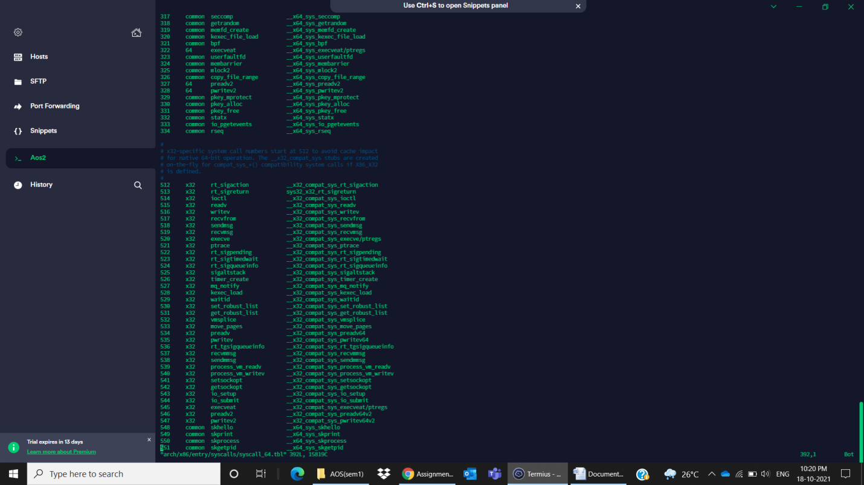

sudo vim include/linux/syscalls.h

by the above command we can see all the prototypes of predefined syscalls , here adding prototypes of our system calls at the last (shown below..)

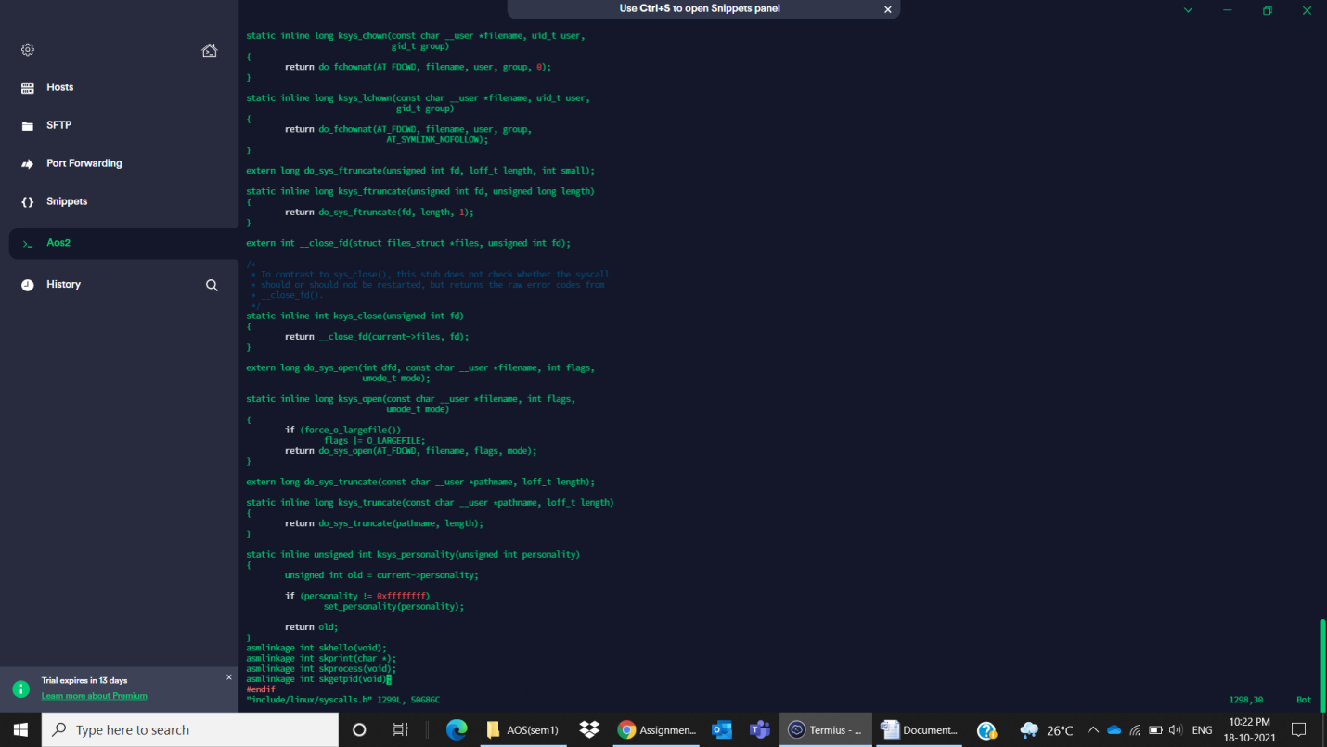

Then in the kernel , we will write our system call definition as .c files

1)skhello.c

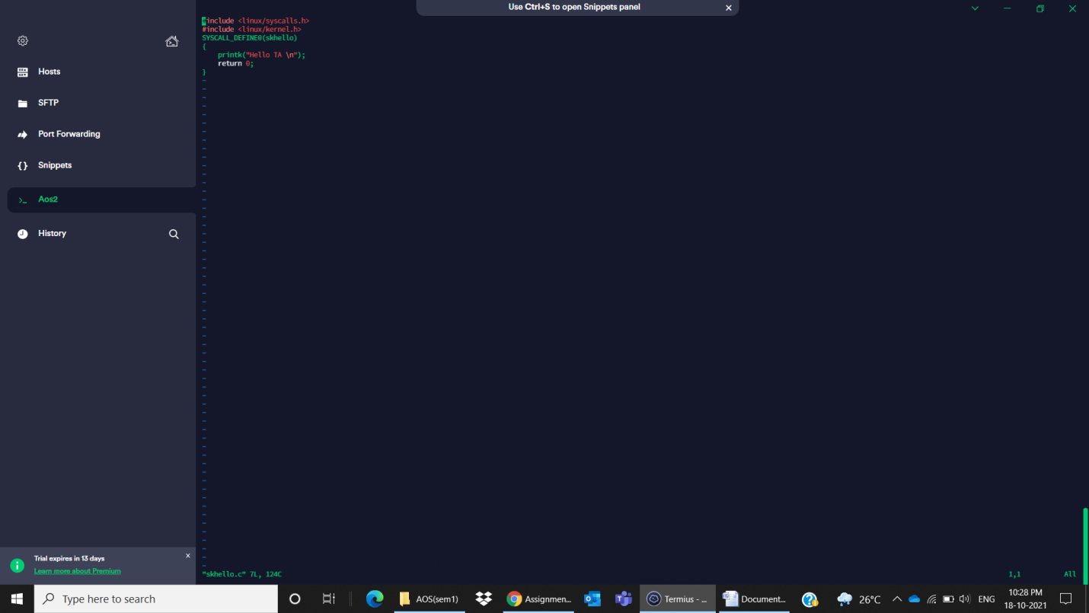

2)skprint.c

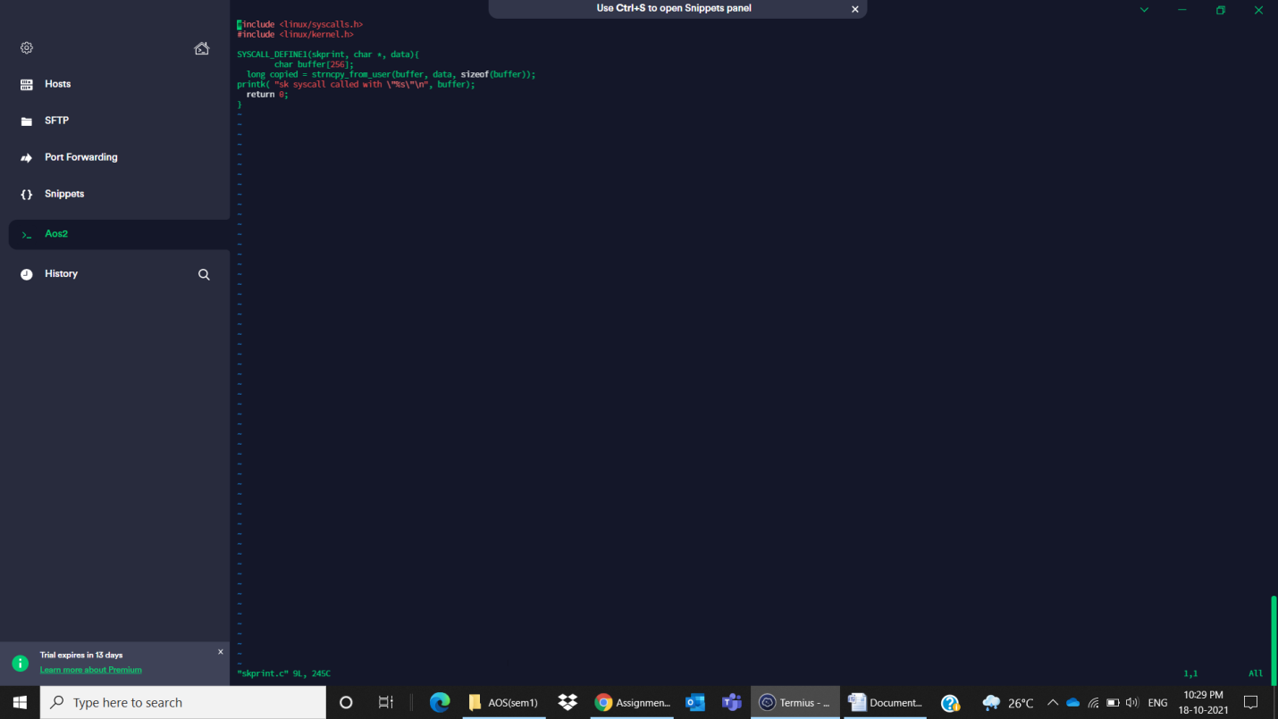

3)skprocess.c

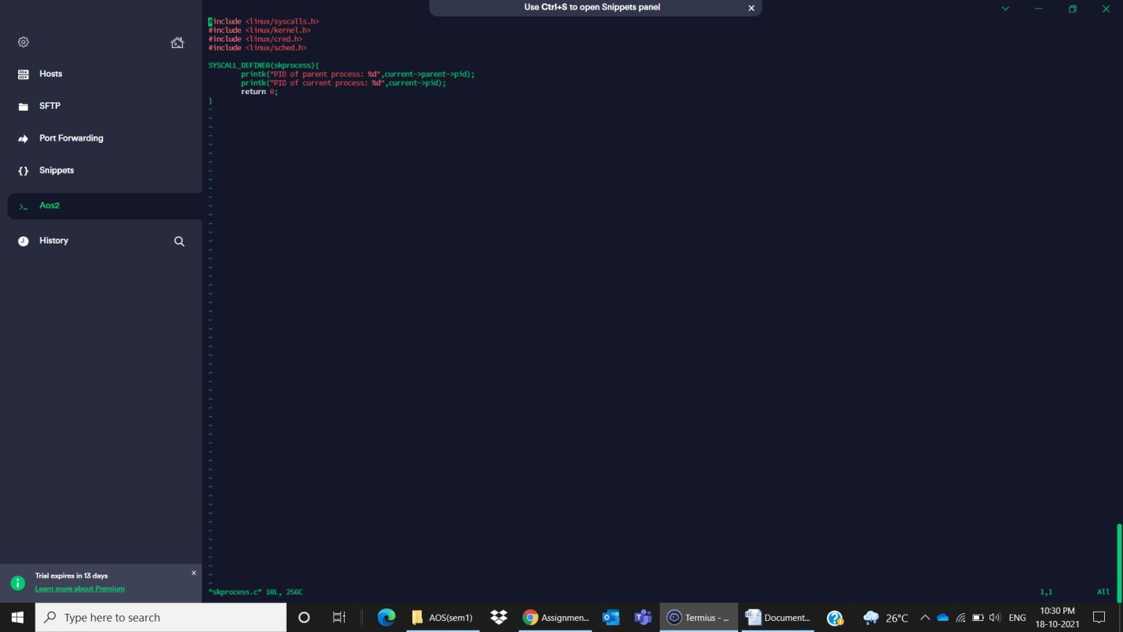

4)skgetpid.c

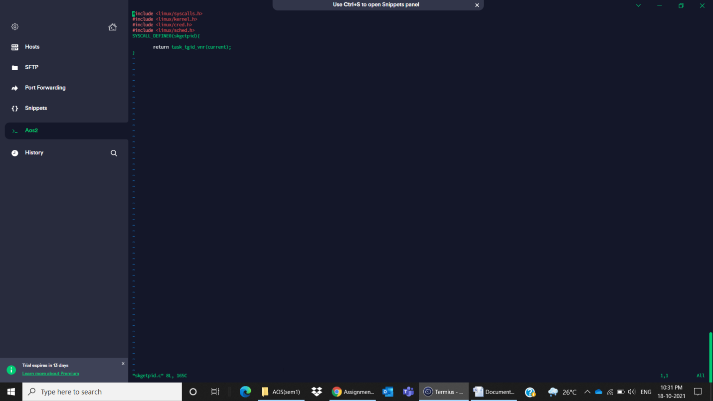

Then update the Makefile of kernel i.e., add our .o file of syscall as receipe(shown below..)

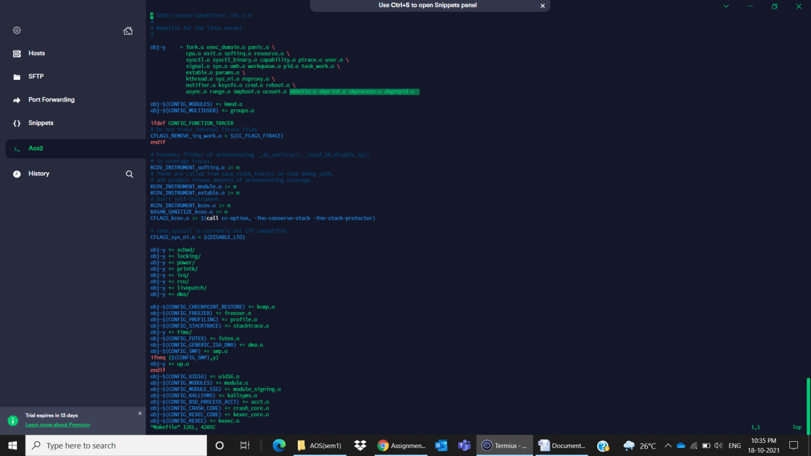

At last compile by below some commands…and rebbot

sudo make olddefconfig

sudo make prepare

sudo make -j5 sudo make -j5

modules_install sudo make install

sudo reboot

for checking the output create a main.c file